**Toll Plaza Collection**

Konda Manish Kumar, Mohith, Rajesh, Siva

Integrated MTech Software Engineering of

Vellore Institute of Technology

Chennai, Tamil Nādu, India

[kondamanish.kumar2019@vitstudent.ac.in](mailto:kondamanish.kumar2019@vitstudent.ac.in)

[mohith.a2019@vitstudent.ac.in](mailto:mohith.a2019@vitstudent.ac.in)

[rajesh.b2019@vitstudent.ac.in](mailto:rajesh.b2019@vitstudent.ac.in)

[siva.c2019@vitstudent.ac.in](mailto:siva.c2019@vitstudent.ac.in)

**Abstract-**Toll Plaza collection is widely used, for this through this paper we came up with Toll Plaza Collection system, this system reduces cash handling which aids in enhanced audit control by user account. It provides users the flexibility of paying their toll amounts with both rfid and from account. In this paper we explained how the system is useful, how it works and conclusion.

1. **INTRODUCTION**

The toll plaza collection system will be useful to the user who travel through the tolls by paying the amount to the tolls before head for the journey for a particular toll or for all tolls from one place to destination. First the user will give the travelling details of vehicle number, vehicle type and the destination. After the travelling details the user will give toll details of for which toll the user want to pay or for all tolls and the user can pay amount for single trip or return trip also available. If the user paid for the tolls, then at the tolls the payment will be verified using rfid scanner (qr code).

1. **MOTIVATION**

The motivation for this project is that as we can see that so many people are traveling in their vehicles. As we traveling, we can find the number of toll gates on the way. We find it very difficult to wait in the queue for such a long time. At present, manual toll collection is the most widely used collection method in the world. Due to manual intervention, the processing time at toll plazas is highest. Traffic congestion at Toll plazas leads to a huge economical loss in terms of fuel wastage and also causes pollution.

1. **OBJECTIVE**

This system reduces cash handling which aids in enhanced audit control by user account. It will help to reduce the waiting time at the tolls. It provides users the flexibility of paying their toll amounts with both rfid and from account. User can pay amount to the tolls before head for the journey. User can pay amount to the tolls from one destination to another destination.

1. **LITERATURE SURVEY**

**ONLINE TOLL GATE PAYMENT SYSTEM USING RFID** (VIJI AMUTHA MARY)

This Online Toll Gate Payment system provides online payment for tollgates and detecting theft vehicles using the RFID technology along with micro controller and GSM modem. Once the source and destination is selected the number of tollgates is listed and the payment is done. In all the tollgates where the user has made the payment, the number plate of the vehicle is detected automatically and is allowed to travel further.

**ONLINE TOLL PAYMENT SYSTEM (**FATHIMA, JAYAMALA, KEERTHIKA**)**

It is used to find the position of the vehicle as well as toll plazas accurately. When the destination toll is near to the user, an alert message is sent to the user. 1-2 km before the toll plaza, a notification will be sent to the mobile phone of the approaching user with Toll Name and applicable Toll Fee. Payment can be facilitated through mobile wallets. An electronic receipt is generated, with QR code which can be scanned by the QR readers at Toll Booth.

**GPS BASED TOLL COLLECTION SYSTEM**

This project aims in designing a system, which automatically identifies the vehicle that advance towards the toll plazas and observes the vehicle number and the time of arrival. If matches exist between vehicle data and GPS data, then predetermined amount is automatically taken from the user account.

**TOLL BOOTH COLLECTION USING LI-FI** (SHIVANI SHARMA, AAYUSHI SHAH, SAIFALLI SHAIKH, HARSH SHIRKE, PROF. GAURI BHANGE)

At the toll plaza, once the vehicle’s Li-Fi transmitter is paired with the Li-Fi receiver, the system at toll plaza automatically identifies the vehicle details. The Li-Fi system uses Li-Fi which collects information of vehicle passing through the toll plaza and automatically debits the toll amount from prepaid account of vehicle owner.

**TOLLZ-E (ONLINE TOLL SYSTEM)**

RFID tags provided to the users are scanned through RFID reader fixed at toll booths in specific positions and online transactions are carried out regarding the specific RFID tag number of user.

**SMART TOLL PAYMENT SYSTEM USING ANDROID APPLICATIONS** (SRISAILANATH, JHANSIRANI P, B S RAMYA REDDY, ANITHA B L, LAXMI SWETHA YERRAMSETTY)

In this application where admin will verify the tollgater with his/her detail, clients get registered in this app and pay his /her tollgate payments which decreases the manual work and hence increases the vehicle speed passing by the toll booth. Also, it allows the vehicles just to pass through the booth by just showing the QR code. This result reducing the traffic pattern at the toll collecting booths.

**NOVEL ONLINE VEHICLE TOLL PAYMENT SYSTEM FOR INDIAN NATIONAL HIGHWAYS** (DR.G.SUSEENDRAN, DR.D.AKILA, DR.A.SASI KUMAR)

In this paper, a design for automatic license plate number Recognition system is to be developed. A novel genetic algorithm is introducing to detect and extract the license plate. This performs two level of segmentation process. Then Connected Component Analysis technique is used to extract individual characters i.e., numbers and alphabets in the image. Then followed by template matching method with loaded database, where the database consists of 10 to 15 image samples. As a result of Template matching system, we will get the recognized numbers from image to Text format.

**ONLINE TOLL PAYMENT** (MUDDU BASAVANA GOUDA, MRS. R. LATHA)

In this paper they are going to take a ticket in advance before going to travel and the payment is done through online and the receipt is having been receiving through Email, there in the toll, the toll employee will verify the payment and allow the user to cross the toll.

1. **SYSTEM SPECIFICATIONS**

**HARDWARE REQUIREMENTS**

* Rfid scanner
* Computer
* Micro controller

**SOFTWARE REQUIREMENTS**

* Operating system(windows)
* Xampp server
* NetBeans ide

1. 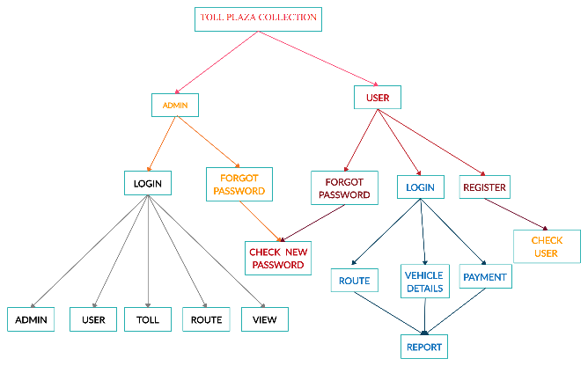**SYSTEM DESIGN**

Fig.1. Functional decompose diagram

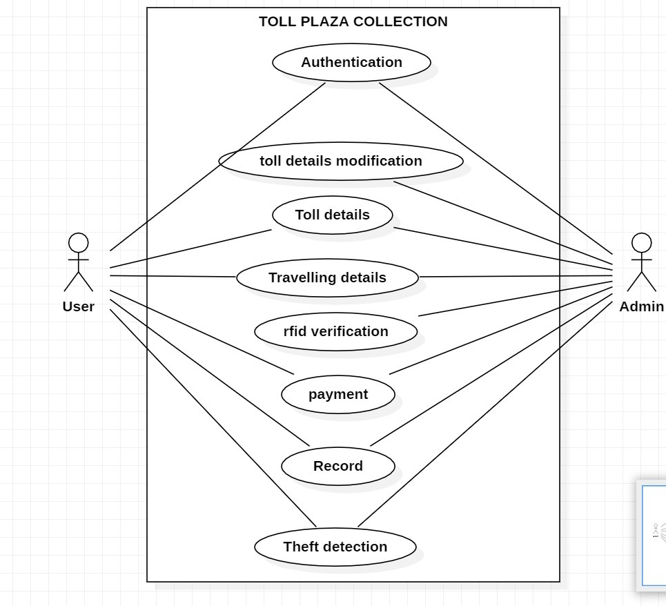

Fig.2.Use case diagram

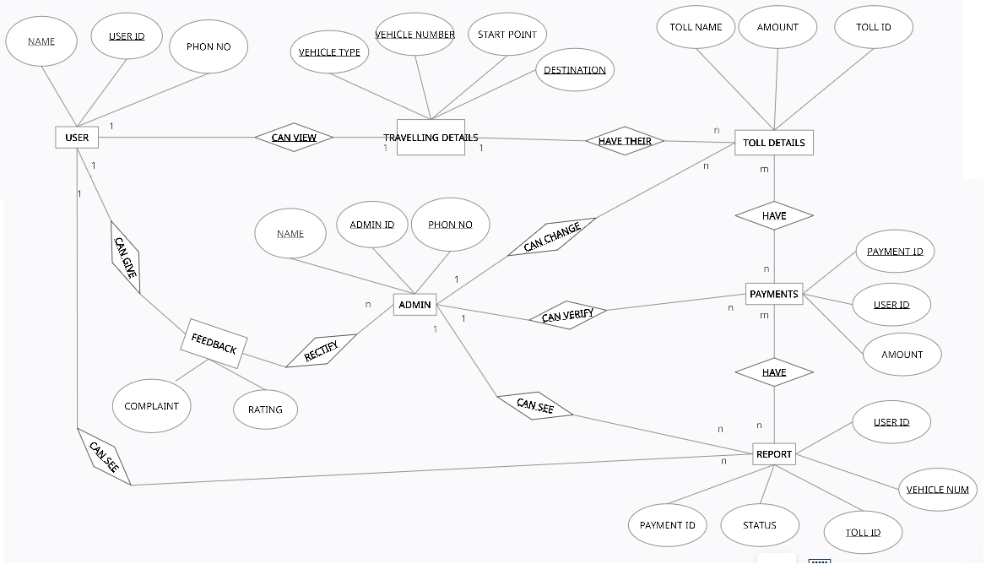

Fig.3.ER Diagram

1. **MODULES**

**AUTHENTICATION**Authentication is to validate the user’s credentials and create the user and admin.**TOLL MODIFICATION**The admin will be having the function to change the change details of tolls.**RFID VERIFICATION**The admin will scan the qrcode and verify the user’s payment.

**TRAVELLING DETAILS**The user will give the vehicle, start and destination places with which type of details.**TOLL DETAILS**After giving the travelling details here the details of the tolls.**PAYMENT**The payment will be done using the wallet or through the online mode.

**RECORD**Records will store the details of the users, tolls and payment details.**THEFT DETECTION**If the user raised the complaint when they lost vehicle, then if that vehicle crossed the toll, then the vehicle detected and notified the user.**REFUND**If the user not crossed the toll within 24 hours the amount will be credited to user’s account.

1. **SYSTEM IMPLEMENTATION**

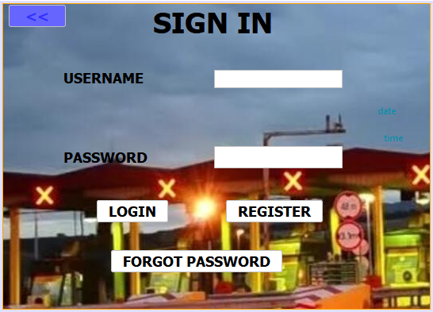

**Fig.4. Sign in**

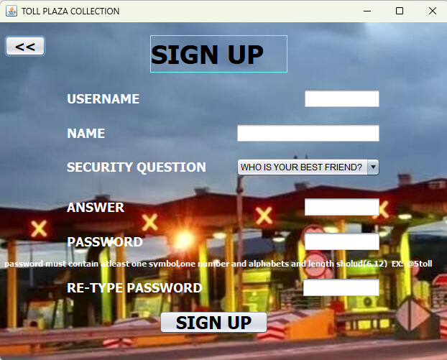

**Fig.5. Sign up**

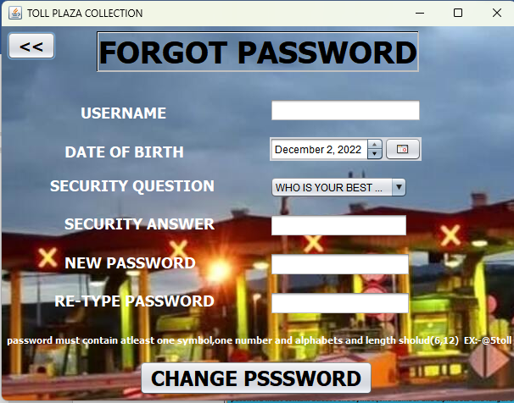

**Fig.6.Forgot password**

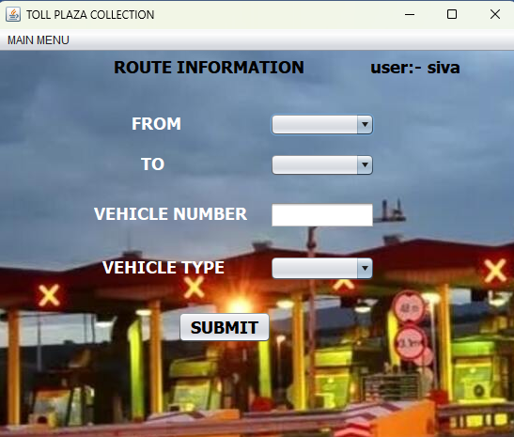

**Fig.7.Travelling details**

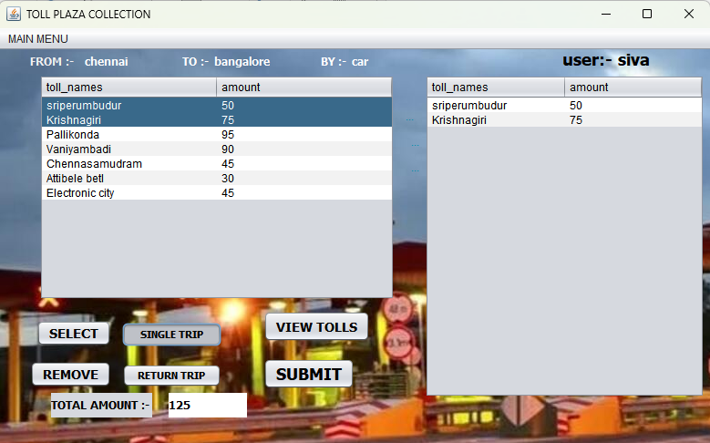

**Fig.8.Toll details**

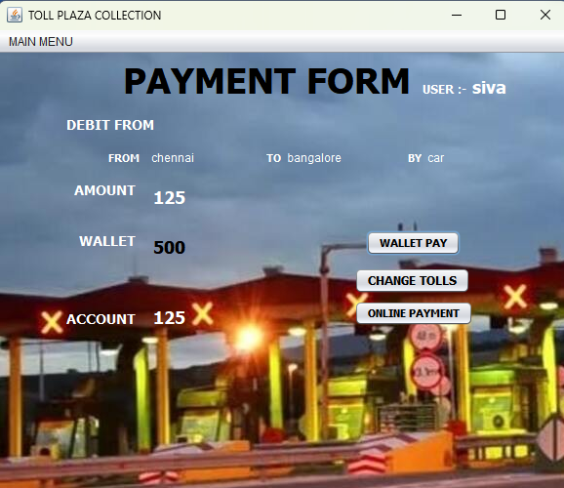

**Fig.9.Payment**

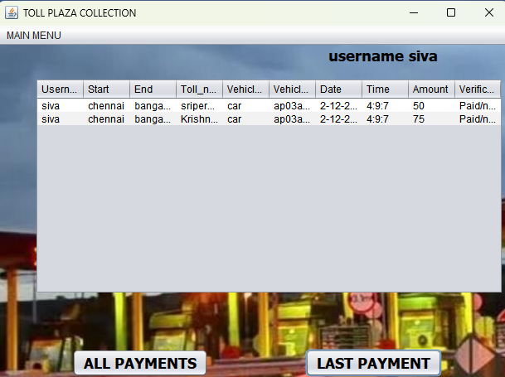

**Fig.10.History**

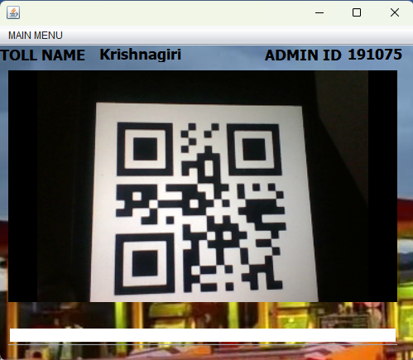

**Fig.11.Rfid Scanner**

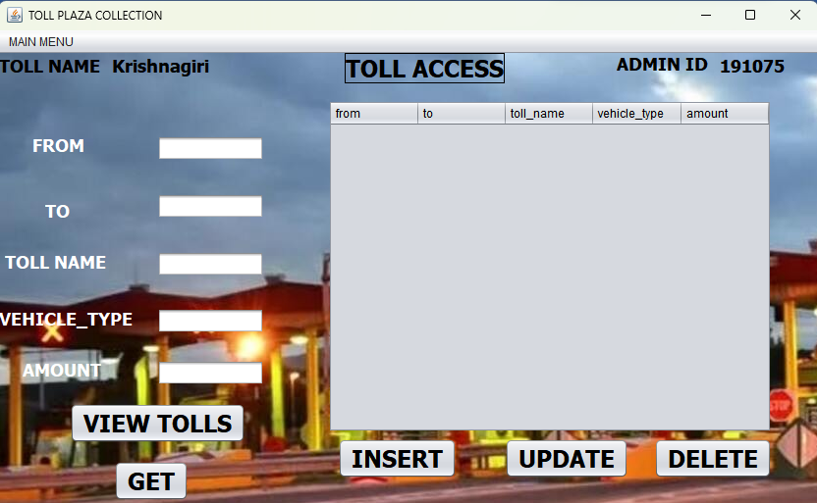

**Fig.12.Toll details modification**

1. **RESULTS AND DISCUSSION**

Results of the system were met the objectives mentioned above the User can pay amount to the tolls before head for the journey. User can pay amount to the tolls from one destination to another destination. In future the system can have alternate requirements instead of qrcode we can proceed with GPS or LIFI light transmitter.

1. **CONCLUSION**

In this report we done some literature survey according those papers we got some ideas and we followed Online toll gate payment system using RFID paper, using the methods of that project we came up with the project Toll Plaza Collection, this system will be useful to the user who travel through the tolls by paying the amount to the tolls before head for the journey for a particular toll or for all tolls from one place to destination. If the user paid for the tolls, then at the tolls the payment will be verified using rfid scanner (qr code). If the user not crossed the toll within 24 hours the user will get the refund amount how much user paid to the that toll. If the user lost vehicle and raised complaint, if that vehicle crossed toll, then the user will be notified.

1. **REFERENCES**

**[**1]. Viji Amutha Mary, Online toll gate payment system using RFID

[2]. Fathima, Jayamala, Keerthika, Online Toll Payment System, July 2018

[3]. Shivani Sharma, Aayushi Shah, Saifalli Shaikh, Harsh Shirke, Gauri Bhange , Toll Booth Collection using Li-Fi,

Vol. 7, Issue 5, May 2018

[4]. Srisailanath, JhansiRani P, B S Ramya Reddy, Anitha B L, Laxmi Swetha Yerramsetty, Smart Toll Payment System Using Android Applications, 2019 IJSRCSEIT, Volume 5, Issue 3, ISSN : 2456-3307

[5]. Dr.G. Suseendran, Dr.D.Akila, Dr.A. Sasi Kumar, Novel Online Vehicle Toll Payment System for Indian National Highways, Volume 8, Issue XII, DECEMBER/2018

[6]. Muddu Basavana Gouda, Mrs. R. Latha, ONLINE TOLL PAYMENT, volume:4/Issue:05/May-2022